**CSC 555 Assignment 3**

**Yiyang Yang**

**Part 1**

a).

Mapper: Keys are the lo_orderdate and d_datekey, values are the sum of lo_extendedprice, lo_discount and d_yearmonth.

Reducer: Show the sum of the lo_extendedprice, for each lo_orderdate same as d_datekey, and then sort them when d_yearmonth is equal to Jan1994, and lo_discount is between 4 and 6.

b).

Mapper: Key is the variable d_month, value is the count of the variable d_sellingseason.

Reducer: Group all the d_sellingseason into different d_month, and then order them according to the correponding d_sellingseason.

**Part 2**

a).

2 * 75 + 2 * 2500 / 60 = 150 + 83.3 = 233.3 mins

b).

There are 75 blocks divided into 30 blocks for 2 rounds, and 15 blocks left for the third round. 2 * 3 = 6 mins. Time for reducer 2500 * 2 / 30 / 60 = 2.8 mins. Time is 6 + 2.8 = 8.8 mins

c).

75 blocks are divided into 50 blocks for 1 round, and 25 blocks left for second round. 2 * 2 = 4 mins. Time for reducer 2500 * 2 / 50 / 60 = 1.7 mins. Time is 4 + 1.7 = 5.7 mins

d).

75 blocks are divided into 100 block for 1 round. 2 * 1 = 2 mins. Time for reducer 2500 * 2 / 75 /60 = 1.1 mins. Time is 2 + 1.1 = 3.1 mins

e).

I don’t think combiner will affect the runtime of this job, since combiner is used on reducer, the runtime of reducer on this problem will not be affected by the combiner that much.

**Part 3**

a).

i).

I think HDFS will reform the clusters with three factors.

ii).

I think MapReduce engine will store the data in the memory and then restart the engine when node failure.

b).

I think local file system is the place Mapper store the output before sent to Reducer.

**Part 4**

a). After compressed A4;B3;A5;B4;A4, compression ratio is 14/20 = 0.7.

b). After compressed ABCD5, compression ratio is 5/20 = 0.25.

c). Compressed ratio is 1.

**Part 5**

‘Swap.py’

#!/usr/bin/python

import sys

for line in sys.stdin:

line = line.strip().split('\t')

name = line[1]

first, last = name.split(‘\t’)

print '\t'.join([last, first])

CREATE TABLE part (

p_partkey int,

p_name varchar(22),

p_mfgr varchar(6),

p_category varchar(7),

p_brand1 varchar(9),

p_color varchar(11),

p_type varchar(25),

p_size int,

p_container varchar(10)

)

ROW FORMAT DELIMITED FIELDS TERMINATED BY ‘|’ STROED AS TEXTFILE;

LOAD DATA LOCAL INPATH ‘home/ec2-user/part.tbl’ OVERWRITE INTO TABLE part;

ADD FILE /home/ec2-user/swap.py;

SELECT TRANSFROM(p_name) USING ‘python swap.py’ AS (p_name) FROM part;

CREATE TABLE PartX(

p_partkey int,

p_name varchar(22),

p_mfgr varchar(6),

p_category varchar(7),

p_brand1 varchar(9),

p_color varchar(11),

p_type varchar(25),

p_size int,

p_container varchar(10)

)

ROW FORMAT DELIMITED FIELDS TERMINATED BY ‘\t’ STROED AS TEXTFILE;

INSERT OVERWRITE TABLE PartX SELECT TRANSFORM(p_name) USING ‘python swap.py’ AS (p_name) FROM part;

**Part 6**

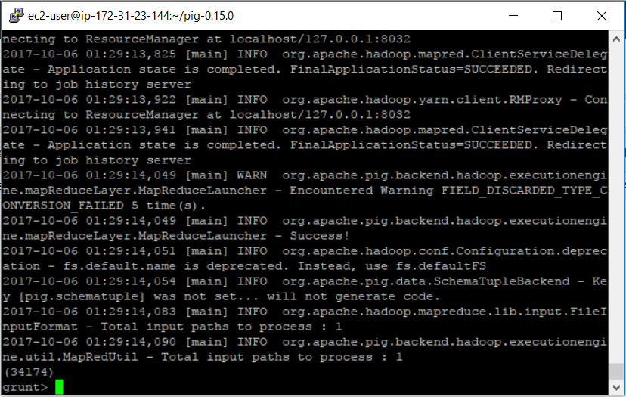

There are 34174 rows in the table.

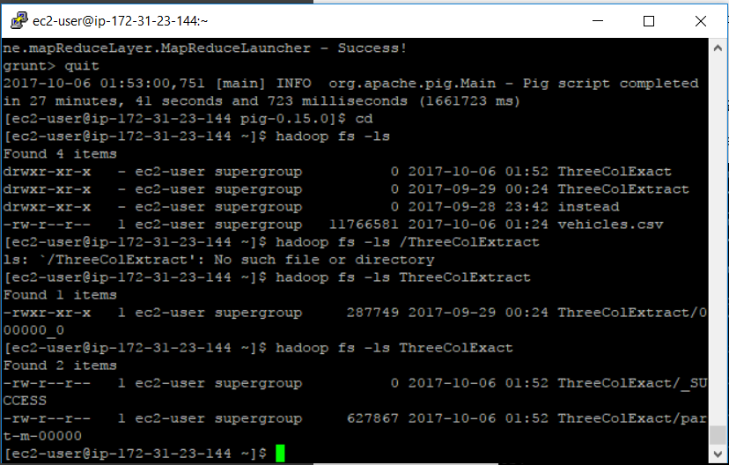

The size of the new file is 627867 bytes.